Significant Event and Incident Policy (England)

Version: | Review date: | Edited by: | Approved by: | Comments:
2.1 | June 2022 |  | AJH

Table of contents
1 Introduction 4
1.1 Policy statement 4
1.2 Principles 4
1.3 KLOE 4
1.4 Status 6
1.5 Training and support 6
2 Scope 6
2.1 Who it applies to 6
2.2 Why and how it applies to them 6
3 Definition of terms 7
3.1 Overarching 7
3.2 Patient safety 7
3.3 Serious incident 7
3.4 Patient safety incident 7
3.5 Incident 7
3.6 Near miss 7
3.7 Significant event 7
3.8 Significant event analysis 8
3.9 Never events 8
3.10 Care Quality Commission 8
3.11 National Reporting and Learning System (NRLS) 8
3.12 Learn from patient safety events (LFPSE) service 8
3.13 Information Commissioner’s Office (ICO) 8
4 Significant event analysis 9
4.1 Rationale 9
4.2 Involving the team 9
4.3 Aims of SEA 9
4.4 What constitutes a SEA? 9
4.5 Benefits of significant event analysis 10
5 A health and safety event or incident 10
5.1 Supporting policies 10
6 Analysis of an event or incident 11
6.1 Root cause analysis 11
6.2 How to use root cause analysis (RCA) 11
6.3 Audit and learning from an event or incident 11
7 Significant event reporting 13
7.1 Reporting advice 13
7.2 What to report 13
7.3 Categories of incidents to be reported 14
7.4 Reporting SEs within a PCN 14
7.5 Benefits of incident reporting 14
8 Tools for reporting events and incidents 14
8.1 Reporting to the NRLS 14
8.2 Learning from patient safety events service 16
8.3 Data security and protection toolkit (DSPT) 16
8.4 Information Commissioners Office (ICO) 17
8.5 Aide 18
9 Serious incidents 18
9.1 Assessing whether an incident is a serious incident 18
9.2 Can a ‘near-miss’ be a serious incident? 18
9.3 Principles of a serious incident 19
9.4 Reporting a serious incident 20
9.5 Ongoing management and required actions 20
10 Demonstrable evidence 20
10.1 CQC inspections 20
11 Recording SIs, SEs and PSIs 21
11.1 Template usage 21
11.2 Practice lead 22
11.3 Team meetings 22
12 Summary 22
Annex A – Patient safety incident report e-form 27
Annex B – Easy guide for reporting events and incidents 28

Introduction
  - Policy statement

Providing safe, effective, high-quality patient care is the aim of all staff at Grey Road Surgery. Given the complexity of primary care and the associated pressures resulting in increased clinical and administrative workloads, it is inevitable that significant events (SE), patient safety incidents (PSI) and other incidents will occur.

Throughout this document, the terminology used is in line with a change in language and understanding of significant events and incidents since 2017 when RCGP published an updated report.

For the purposes of this document, three categories of incidents have been described:

- Significant event
- Patient safety incident
- Non-clinical incident

The rationale for this is to distinguish and simplify the relevance of incident reporting for all staff.

Clinicians need to review and record significant events for audit and revalidation purposes, practice managers need to report these for governance purposes and all staff need to easily understand what/how/why and when to report incidents.

This policy will outline the procedure for reporting SE, PSIs and incidents at Grey Road Surgery and applies to reporting incidents from a patient safety aspect, coupled with those that may compromise staff safety concerns.
  - Principles

This policy will illustrate the organisation’s commitment to the safety of the patient population. By promoting a learning culture, staff are encouraged to report SE, PSIs and incidents that will foster learning and help to prevent the recurrence of similar incidents in the future.

This policy is to be read in conjunction with both the Duty of candour policy and the Data Protection Toolkit Guidance.
  - KLOE

The Care Quality Commission would expect any primary care organisation to have a policy to support this process and this should be used as evidence of compliance against CQC Key Lines of Enquiry (KLOE)
Specifically, Grey Road Surgery will need to answer the CQC Key Questions on “Safe” and “Well-Led”. The following is the CQC definition of Safe:

By safe, we mean people are protected from abuse* and avoidable harm. *Abuse can be physical, sexual, mental or psychological, financial, neglect, institutional or discriminatory abuse.

CQC KLOE S6 | Are lessons learned and improvements made when things go wrong?
S6.1 | Do staff understand their responsibilities to raise concerns, to record safety incidents, concerns and near misses and to report them internally and externally where appropriate?
S6.2 | What are the arrangements for reviewing and investigating safety and safeguarding incidents and events when things go wrong?  Are all relevant staff, services, partner organisations and people who use services involved in reviews and investigations?
S6.3 | How are lessons learned and themes identified and is action taken as a result of investigations when things go wrong?
S6.4 | How well is the learning from lessons shared to make sure that action is taken to improve safety?  Do staff participate in and learn from reviews and investigations by other services and organisations?
S6.5 | How effective are the arrangements to respond to relevant external safety alerts, recalls, inquiries, investigations or reviews?

The following is the CQC definition of Well-led

By well-led, we mean that the leadership, management and governance of the organisation assures the delivery of high-quality and person-centred care, supports learning and innovation and promotes an open and fair culture.

CQC KLOE W6 | Is appropriate and accurate information being effectively processed, challenged and acted on?
W6.4 | Are there effective arrangements to ensure that the information used to monitor, manage and report on quality and performance is accurate, valid, reliable, timely and relevant?  What action is taken when issues are identified?
W6.6 | Are there effective arrangements to ensure that data or notifications are submitted to external bodies as required?
  - Status

The organisation aims to design and implement policies and procedures that meet the diverse needs of our service and workforce, ensuring that none are placed at a disadvantage over others, in accordance with the Equality Act 2010. Consideration has been given to the impact this policy might have in regard to the individual protected characteristics of those to whom it applies.

This document and any procedures contained within it are non-contractual and may be modified or withdrawn at any time. For the avoidance of doubt, it does not form part of your contract of employment.
  - Training and support

The organisation will provide guidance and support to help those to whom it applies to understand their rights and responsibilities under this policy. Additional support will be provided to managers and supervisors to enable them to deal more effectively with matters arising from this policy.

NHS Improvement has produced a video outlining the importance of reporting patient safety incidents to the National Reporting and Learning System (NRLS). A further video outlines NHS Improvement’s patient safety strategy and the new digital system to support patient safety learning especially in GP organisations.
- Scope
  - Who it applies to

This document applies to all employees of the organisation and other individuals performing functions in relation to the organisation, such as agency workers, locums and contractors.

Furthermore, it applies to clinicians who may or may not be employed by the organisation but who are working under the Additional Roles Reimbursement Scheme (ARRS).
  - Why and how it applies to them

It is the responsibility of all staff to ensure that they recognise, respond to and take the necessary actions regarding SE, PSIs and incidents. Staff must operate in an open and transparent manner, acknowledging that mistakes happen and take the subsequent necessary actions to report all incidents, thereby further reducing the risk of recurrence and ensuring that a high level of patient care is consistently delivered.

Furthermore, staff are required to share best practice as SE, PSIs and incidents can arise through positive actions.
- Definition of terms
  - Overarching

Definitions are taken from both the World Health Organisation (WHO) International Classification for Patient Safety and the RCGP Reporting and learning from patient safety incidents in general practice – A practical guide (pp35).
  - Patient safety

The reduction of risk of unnecessary harm associated with healthcare to an acceptable minimum which refers to the collective notions of given current knowledge, resources available and the context in which care was delivered weighed against the risk of non-treatment or other treatment.
  - Serious incident

Serious incidents are events in healthcare where the potential for learning is so great, or the consequences to patients, families and carers, staff or organisations are so significant, that they warrant using additional resources to mount a comprehensive response.

Serious incidents can extend beyond incidents that affect patients directly and include incidents that may indirectly impact patient safety or an organisation’s ability to deliver ongoing healthcare.
  - Patient safety incident

An event or circumstance that could have resulted, or did result, in unnecessary harm to a patient
  - Incident

An event or circumstance that could have resulted, or did result, in unnecessary harm to a patient (intentionally the same as 3.3)
  - Near miss

An incident that did not reach the patient
  - Significant event

Any unintended or unexpected event that could or did lead to harm of one or more patients and this includes incidents that did not cause harm but could have done or where the event should have been prevented.

  - Significant event analysis

A case-by-case analysis to encourage the whole healthcare team involved in a case or incident to have a supportive discussion. The aim is to use this as a process to allow reflection and learning from the incident and so improve care.

Never events

Never events are serious incidents that are entirely preventable because guidance or safety recommendations providing strong systemic protective barriers are available at a national level and should have been implemented by all healthcare providers.

The NHS Never Events Policy and Framework sets out the NHS policy on never events and this framework explains what they are and how staff providing NHS-funded services should identify, investigate and manage the response to them. It is relevant to all NHS-funded care.
  - Care Quality Commission

The independent regulator of all health and social care services in England
  - National Reporting and Learning System (NRLS)

The NRLS is presently the NHS national database of patient safety incidents.

The NRLS has developed a GP e-form that has been specifically designed to make it quick and easy for those working in general practice to submit a report to the NRLS.
  - Learn from patient safety events (LFPSE) service

NHS Improvement is developing a successor to the NRLS. Further information can be sought at Section 6.2.
  - Information Commissioner’s Office (ICO)

The Information Commissioner is the UK’s independent regulator for Data Protection and Freedom of Information.

- Significant event analysis
  - Rationale

Significant event analysis (SEA herein) at Grey Road Surgery is used to identify both good and poor practice. However, the overall aim of the process is to enable reflection and learning thereby enhancing the level of service offered to the patient population.
  - Involving the team

SEA at Grey Road Surgery involves all members of the multidisciplinary team (MDT). Staff must acknowledge that SEAs are centred on whole-team learning and are not used to direct blame.

It should be noted that this is a CQC requirement as detailed within GP Mythbuster No 3 and as detailed below in the suggested CQC aims of an SEA.
  - Aims of SEA

The aims of completing SEAs are to:

- Identify events in individual cases that have been critical and to improve the quality of patient care from the lessons learnt

- Instigate a culture of openness and reflective learning, not individual blame or self-criticism

- Enable team-building and support following stressful episodes

- Enable the identification of good as well as suboptimal practice

- Be a useful tool for team and individual continuing professional development, identifying group and individual learning needs

- Share learning between teams within the NHS where adverse events occur at the ‘overlap’ or in shared domains of clinical responsibility (such as ‘out of hours’, discharge problems, etc.)
  - What constitutes a SEA?

Examples of significant events can be very wide-ranging and can reflect good as well as poor practice and can include:

- New cancer diagnoses
- Coping with a staffing crisis
- Complaints or compliments received by the practice
- Breaches of confidentiality
- A sudden unexpected death or hospitalisation of a patient
- Prescribing errors
- Positive cervical smears
- Positive mammography
- Important messages not relayed
- Suspected meningitis
- An unsent referral letter
- Wrong/incorrect treatment
- Drug interaction
- Delayed diagnosis
- Loss of care data
- Health and safety concerns or breach
  - Benefits of significant event analysis

Undertaking a SEA will enable the practice team to:

- Reflect on the incident
- Undertake root cause analysis
- Discuss and implement preventative measures
- Enhance learning
- Demonstrate a culture of openness and transparency
- Improve patient care and experience
- A health and safety event or incident

Supporting policies

At Grey Road Surgery we have a library of policies and guidance documents that can support an incident or event that involves a health and safety event. Should there be such an incident, then initial reference is to be made to the Health and Safety Policy and reported as per the RIDDOR requirements.

Other specific and supporting policies may also be required, such as:

- Accident Reporting Policy
- Fire Safety Policy
- First Aid Policy
- Manual Handling Policy
- Panic Alarms Policy and Procedure (part of Buildings Policies)
- Practice Security and Risk Assessment Policy
- Safe Water Policy (Part of Buildings Policies)

Other supporting documents include:
- COSHH Risk Assessment Guidance Document (Part of Building Policies)
- COVID-19 Risk Assessment – An Aide Memoire
- Risk and issues guidance document
- Risk assessment guidance document
- Analysis of an event or incident

Root cause analysis

Root cause analysis (RCA) is defined as a collective term that describes a wide range of approaches, tools and techniques used to uncover the causes of problems.
  - How to use root cause analysis (RCA)

RCA can be raised for an SI, SE or PSI to understand why the incident occurred in the first place and, by doing so, identify areas for improvements that may prevent the incident from being repeated.

Repeatedly asking the question 'why?' (use five as a rule of thumb) can quickly identify the source of an issue or problem, allowing the focus of resources in the right areas.

An example of root cause analysis using ﬁve whys would be:

The Five Whys
1 | There was a delay in the patient receiving oxygen when suffering with a medical emergency | Why?
2 | The oxygen was not readily available | Why?
3 | The oxygen bottle was empty and had not been replaced | Why?
4 | The patient was being tended to by a locum member of staff who did not know where the emergency equipment was located and no emergency equipment checks had taken place | Why?
5 | The regular member of staff was absent through sickness and replacement staff had not been tasked to undertake the emergency checks | Why?

The source of the problem in this case quickly becomes apparent. At Grey Road Surgery, root cause analysis is routinely carried out to identify the cause of all incidents.

Audit and learning from an event or incident

Following any incident or event, part of the management response will be to instigate an investigation that includes audit. The purpose of having an audit is to:

- Identify and highlight evidence-based practice
- Identify areas for improvement and enhance patient safety
- Provide data that can be used to review the effectiveness of service delivery
- Enhance multidisciplinary team communication
- Improve cross-functional working within the practice

Throughout the audit cycle, all audits will be discussed at the various practice meetings on a quarterly basis, thereby ensuring that all staff are aware of ongoing progress as well as having the opportunity to:

- Discuss the findings of audits
- Learn from any outcome or best practice considerations
- Consider how the changes will be implemented across the organisation

An example of how the audit process works is:

Further reference should be made to GP Mythbuster No 4 - Quality improvement activity

- Significant event reporting
  - Reporting advice

All staff are permitted to raise and complete a SEA. However, to enable learning and prevent similar repeat occurrences, it is requested that staff advise the practice manager of their intention to complete a SEA.

Patient and staff personal identifiable information is not required when completing a SEA and staff should refer to the individuals involved as Patient A, Doctor A, Nurse A, etc.

A safety incident can involve a patient or a staff member. Should an accident occur, then this policy is to be read in conjunction with the Accident reporting policy and the organisation’s risk management policies and procedures.

  - What to report

Clinical and non-clinical patient safety incidents should be reported in cases of patient harm or where there was the potential for harm to have been caused. This includes near misses and the reporting of positive outcomes, i.e., an incident was prevented as a result of effective processes/protocols.

Information on statutory notifications involving patient safety incidents is shown on the CQC’s website under GP Mythbuster 21.
Regulation 18 specifies events or occurrences that affect the health, safety and welfare of people who use services that must be notified to CQC. These include:
- A serious injury to a service user
- Abuse or allegations of abuse
- Incidents that are reported to or investigated by the police
- Any event that stops or may stop the registered person from running the service safely and properly.
The full list is available here.
The CQC only needs to be informed of an applicable incident if it:
- Took place whilst a regulated activity was being provided

- May have been the result of the regulated activity or how it was provided

GP organisation’s are legally obliged to notify certain changes, events and incidents that affect their service or the people that use it under Care Quality Commission (Registration) Regulations 2009 Regulation 18 (2). Incidents include all those that affect the health, safety and welfare of people who use the organisation’s services.
Serious injury to any person using the service is to be reported using the statutory notification form and submitted to HSCA_notifications@cqc.org.uk or via the Provider Portal.

In the event of a requirement to notify a patient death under Regulations 16 and 20, including as a result of confirmed or suspected coronavirus, a different notification form is to be completed and submitted to: HSCA_notifications@cqc.org.uk or via the Provider Portal.
  - Categories of incidents to be reported

In general practice there are a number of events and incidents that need to be recorded and/or reported and this includes the following:

- Significant event (SE) as described at Section 4.4
- Patient safety incidents (PSI) as detailed at Section 3.4
- Non-clinical incidents including:
  - Building issues
  - Health and safety
  - Data breaches
  - Other information governance incidents
  - Financial issues
  - Reporting SEs within a PCN

The provisions within the Network Contract DES highlight that the Network Contract DES Specification has now become part of the individual practice’s primary medical services contract.

Therefore, there is a clear obligation for this organisation to record a specific SEA and/or participate in PCN-wide SEA discussions within our primary care network.
  - Benefits of incident reporting

Reporting upon an incident that compromised patient safety will enable this organisation to:

- Reflect on the incident
- Discuss and implement preventative measures
- Enhance learning
- Demonstrate a culture of openness and transparency
- Meet its requirements under CQC Regulations 2009
- Tools for reporting events and incidents
  - Reporting to the NRLS

NRLS enables patient safety incident reports to be submitted to a national database. This provides the opportunity to ensure that the learning gained from the experience of a patient in one part of the country is used to reduce the risk of something similar occurring elsewhere.
At Grey Road Surgery patient safety incidents are reported using the GPTeamNET SEA Toolkit.
All levels of harm, examples defined below, should be reported even if no actual harm to the patient has occurred:
Term | Definition | Clinical example
No harm | Any patient safety incident that did not result in harm or injury or that had the potential to cause harm but was prevented, resulting in no harm (near miss) | A GP prescribes twice the recommended dose of a new drug which the local community pharmacist picks up when dispensing the prescription.
Low harm | Any patient safety incident that required extra observation or minor treatment | A patient’s home visit is missed; the patient has cellulitis of the right leg; this was picked up the following day resulting in the GP deciding to prescribe I.V. rather than oral antibiotics which need to be delivered by community frailty team.
Moderate harm | Any patient safety incident that resulted in a moderate increase in treatment and which caused significant but not permanent harm | Continuing treatment with warfarin without monitoring INR for 6 weeks. The patient had an upper GI bleed and was admitted to hospital for five days for monitoring and follow-up.  It was noted on admission that the INR was 7.
Severe harm | Any patient safety incident that appears to have resulted in permanent harm. | A patient who is a heavy smoker with a persistent cough is noted to have a suspicious lesion on a chest x-ray.  The GP messages the practice reception to arrange an urgent appointment with the patient, although there is no answer on the patient’s home telephone as he is on holiday. The message to follow up is missed.  Two months later the patient presents with shortness of breath and haemoptysis. He is admitted to hospital via MAU and is diagnosed with lung cancer.
Death | Any patient safety incident that directly resulted in death | A patient is on a repeat prescription for morphine sulphate 10mg twice a day for chronic pain. The patient requests a prescription and, in error, a prescription is issued for morphine sulphate 100mg twice a day.  The medication is dispensed and the patient’s wife, who looks after his medicines, gives her husband 100mg tablets of morphine sulphate. He takes two doses over the next day and then his wife is unable to rouse him in the morning.  He is admitted to hospital where he has a cardiac arrest and dies.
  - Learning from patient safety events service

This new national NHS Learn from patient safety events (LFPSE) service (previously called the patient safety incident management system or PSIMS during its development) is in the final stages of development as a central service for the recording and analysis of patient safety events that occur in healthcare.

NHS Improvement has now commenced the public beta stage where some organisations can begin using the system instead of the NRLS.

LFPSE will replace NRLS and Strategic Executive Information System (StEIS), to offer better support for staff from all health and care sectors.

Further information on LFPSE can be sought at this YouTube clip.
  - Data security and protection toolkit (DSPT)

The Data Security and Protection Toolkit (DSPT) is an online self-assessment tool that was introduced in April 2018 and replaced the Information Governance Toolkit.

The DSPT provides assurance that data security is being observed and personal information is being handled correctly and all organisations with access to NHS patient data are expected to complete the toolkit annually by 31st March and publish their results, although in 2021 and due to COVID-19, the deadline for 2021/22 was extended to 30th June 2021.
Once complete and following publication, this organisation’s performance is measured against the National Data Guardian Ten Data Security Standards.
Refer to the DSPT Toolkit for further information on the Data Security and Protection Toolkit.
  - Information Commissioners Office (ICO)

The Information Commissioner is the UK’s independent regulator for Data Protection and Freedom of Information with key responsibilities under the Data Protection Act 2018 (DPA) and Freedom of Information Act 2000 (FOIA) as well as various other acts.
Further information on the ICO can be found at ico.org.uk.
Grey Road Surgery follows good practice in relation to data protection in order to ensure there is public trust in, and support for, the use of patient data.
UK data protection governance is set out in the DPA 2018 and the UK GDPR.
In relation to this policy, it is likely that most incidents will involve a data breach. According to the ICO, the strict definition of a personal data breach is:
“a breach of security leading to the accidental or unlawful destruction, loss, alteration, unauthorised disclosure of, or access to, personal data transmitted, stored or otherwise processed in connection with the provision of a public electronic communications service”.
This will usually mean that someone other than the data controller has had unauthorised access to personal data for which Grey Road Surgery is responsible. Furthermore, it might also include unauthorised access within Grey Road Surgery such as an employee accidentally altering, using inappropriately or deleting personal data.
You must notify the ICO within 24 hours of becoming aware of the essential facts of the breach.
This notification must include at least:
- Your name and contact details
- The date and time of the breach (or an estimate)
- The date and time you detected it
- Basic information about the type of breach
- Basic information about the personal data concerned
Further information on data breaches can be sought from ICO.
  - Aide

An incident reporting flow chart can be found on page 19 to assist staff at Grey Road Surgery to identify incidents that require prompt and appropriate reporting.
- Serious incidents
  - Assessing whether an incident is a serious incident

NHSE advise within the Serious Incident Framework 2015 that in many cases it will be immediately clear that a serious incident has occurred and further investigation will be required to discover what exactly went wrong, how it went wrong (from a human factor and systems-based approach) and what may be done to address the weakness to prevent the incident from happening again.

Whilst a serious outcome (such as the death of a patient who was not expected to die) can provide a trigger for identifying serious incidents, the outcome alone is not always enough to delineate what counts as a serious incident.

At Grey Road Surgery we will strive to achieve the very best outcomes but this may not always be achievable. Upsetting outcomes are not always the result of error/acts and/or omissions in care although this will be established through thorough investigation and action to mitigate future risks should be determined.
  - Can a ‘near-miss’ be a serious incident?

It may be appropriate for a near miss to be a classed as a serious incident (SI) because the outcome of an incident does not always reflect the potential severity of harm that could be caused should the incident (or a similar incident) occur again.

Deciding whether or not a near miss should be classified as a serious incident should therefore be based on an assessment of risk that considers:

- The likelihood of the incident occurring again if current systems/process remain unchanged

- The potential for harm to staff, patients, and the organisation should the incident occur again

Therefore, this does not mean that every near miss should be reported as a serious incident. However, where there is a significant existing risk of system failure and serious harm, the serious incident process should be used to understand and mitigate that risk.
  - Principles of a serious incident

There are seven key principles in the management of a serious incident:

- Open and transparent

The needs of those affected should be the primary concern of those involved in the response to and the investigation of serious incidents. The principles of openness and honesty are outlined in the Duty of candour policy.

- Preventative

Investigations of serious incidents are undertaken to ensure that weaknesses in a system and/or process are identified and analysed to understand what went wrong, how it went wrong and what can be done to prevent similar incidents occurring again.

- Objective

Those involved in the investigation process must not be involved in the
direct care of those patients affected nor should they work directly with those
involved in the delivery of that care.

- Timely and responsive

Serious incidents must be reported without delay and no longer than two
working days after the incident is identified

- Systems based

The investigation must be conducted using a recognised systems-based investigation methodology that identifies:

- The problems (the what?)

- The contributory factors that led to the problems (the how?) taking into account the environmental and human factors

- The fundamental issues/root cause (the why?) that need to be addressed. Within the NHS, the recognised approach is commonly termed Root Cause Analysis (RCA) investigation

- Proportionate

The scale and scope of the investigation should be proportionate to the incident to ensure resources are effectively used. Incidents that indicate the most significant need for learning to prevent serious harm should be prioritised.

- Collaborative

Serious incidents often involve several organisations. As such, this organisation will work in partnership with others to ensure incidents are effectively managed.
  - Reporting a serious incident

Serious incidents or suspected serious incidents must be declared as soon as this organisation becomes aware of the incident.

Initially these will be discussed between partners and managers although consideration must be made soonest as to the likely requirement that there will be a need to escalate to both NHS England Area Team and Liverpool CCG/ICS

Ongoing management and required actions

Serious incident investigation reports must be shared with key interested bodies including patients, victims and their families. This may also be needed as evidence for regulatory, commissioning and legal proceedings.

NHS E recommended that reports are drafted on the basis that they may become public so issues concerning anonymity and consent for disclosure of personal information are important and should be considered at an early stage in the investigation process.

Those investigating serious incidents can seek advice from the Caldicott Guardian if guidance is needed about the disclosure of patient identifiable information.

Full details of the serious incident management and subsequent investigation process can be sought from the comprehensive NHS document titled: Serious Incident Framework - Supporting learning to prevent recurrence dated 27 March 2015.
- Demonstrable evidence
  - CQC inspections

To satisfy CQC inspectors, Grey Road Surgery will have to provide evidence of the following:

- Staff can and are aware how to prioritise an SI, SE and PSI
- Evidence of information gathering
- Structured team meetings to discuss, investigate and analyse SEs and PSIs
- Outcomes are agreed and changes agreed, implemented and monitored
- SIs, SEs and PSIs are recorded effectively
- All those involved receive a copy of the SEA report (electronically)

At the team meetings to discuss SIs, SEs and PSIs, the CQC will expect to see evidence of the following:

- A complete analysis of the SI, SE or PSI:

  - What happened and why did it happen?
  - Could anything have been done differently?
  - What lessons have been learned?
  - What needs to change and how will this be implemented?
The following are possible outcomes:

- No further action required
- MDT discuss what is deemed best practice/excellent level of care
- Training need/s identified
- There is a requirement for audit
- Immediate actions are required to prevent future events
- MDT discuss lessons learnt

The following diagram illustrates the SE/Incident process:

- Recording SIs, SEs and PSIs
  - Template usage

At Grey Road Surgery all staff must use GP Teamnet for reporting of SEA’s
  - Practice lead

The lead for SIs, SEs and PSIs at Grey Road Surgery is Dr Janet Bliss Snr Partner/Caldicot Guardian and they will be able to provide guidance to individuals should they have any queries or concerns relating to any SE or incident.
  - Team meetings

SEs, PSIs and SIs are a daily occurrence across the NHS. By demonstrating a culture of accurate reporting, this will illustrate a whole-team approach to maintaining a safe and effective environment and the drive to deliver an excellent standard of patient care at Grey Road Surgery
At Grey Road Surgery, team meetings to discuss SEs and incidents will be held monthly and all staff will be invited to attend.
- Summary

An increase in reporting of events and incidents is a sign that an open and fair culture exists where staff learn from things that go wrong.

The CQC will consider that those organisations with a culture of high reporting are more likely to have developed proactive reporting and learning to ensure the services they provide are safe.

Annex A – Patient Safety Incident Report e-form
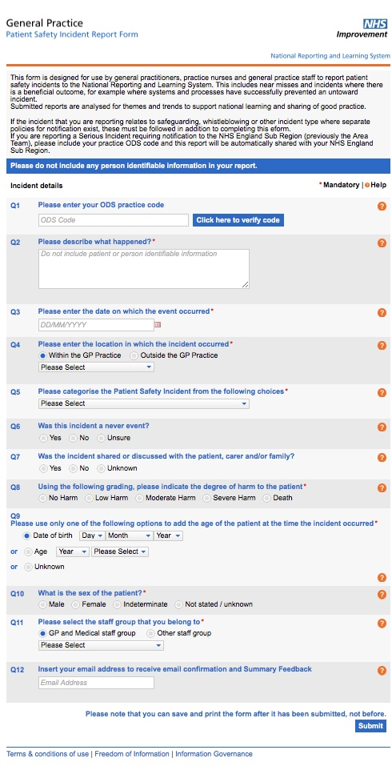

Annex B – Easy guide for reporting events and incidents
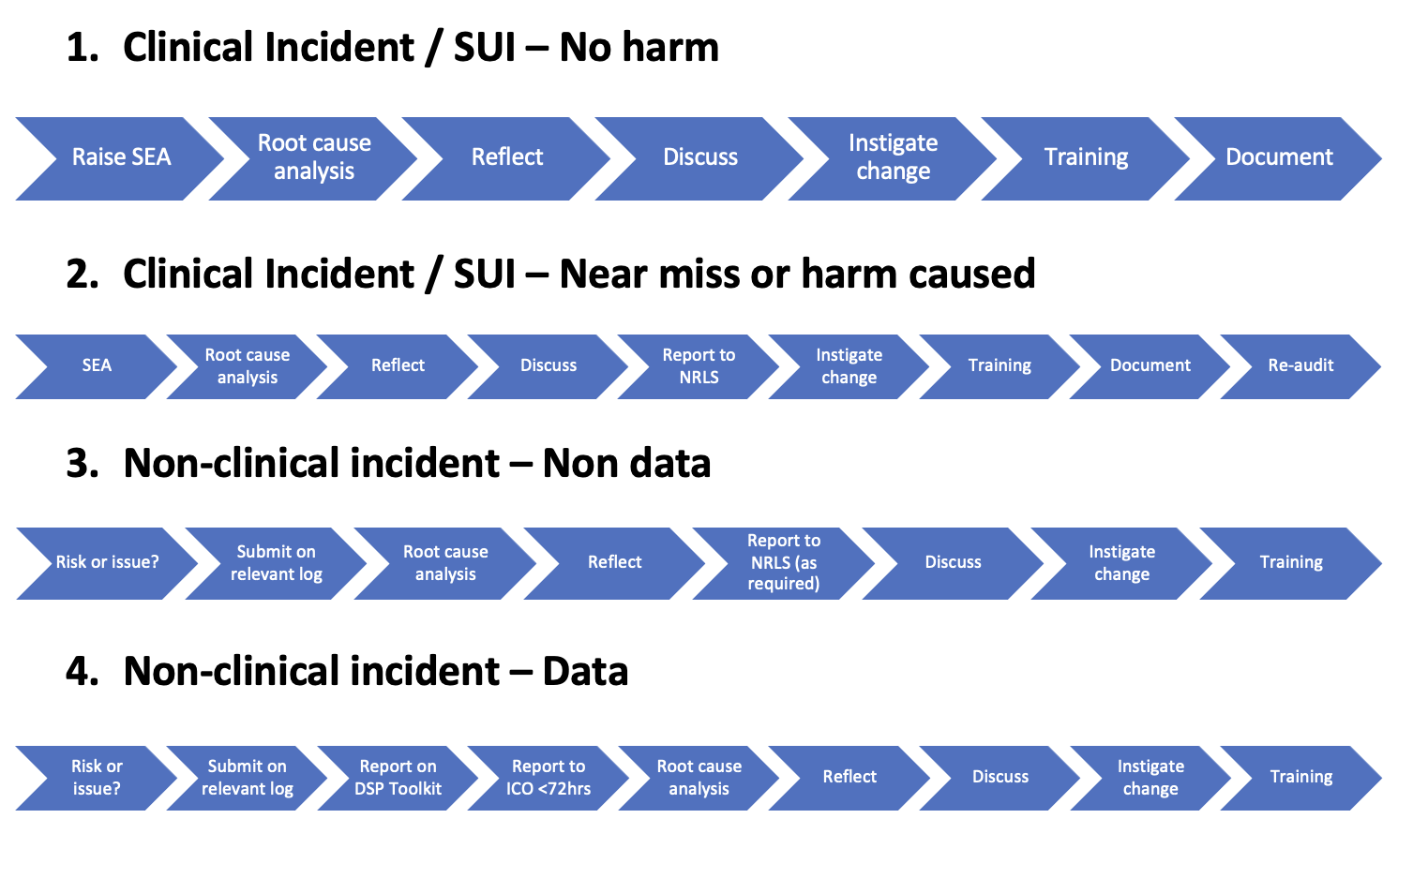

www.rcgp.org.uk
www.cqc.org.uk
Network DES Contract specification 2021/22
NHSE - Serious incident framework
Wessex LMC
GP Mythbuster 3: Significant event analysis
CQC About us
Guide for general practice staff on reporting patient safety incidents to the NRLS
ICO
Care Quality Commission (Registration) Regulations 2009
www.dsptoolkit.nhs.uk
www.digitalsocialcare.co.uk
ico.org.uk

